PROJECT REPORT

1.INTRODUCTION:

1.1 OVERVIEW

1.my project title was preparation and maintaince for keerthi sweets in ZHOHObooks.

2.my project duration was 28 days finished my projects in two days after the starting day.

1.2 PURPOSE

1.account maintained easily.

2.time saving.

It is an easy way to create sales,purchase,order,bills and invoices.

2.PROBLEM DEFINITION AND DESIGN THINKING;

2.1 empathy map

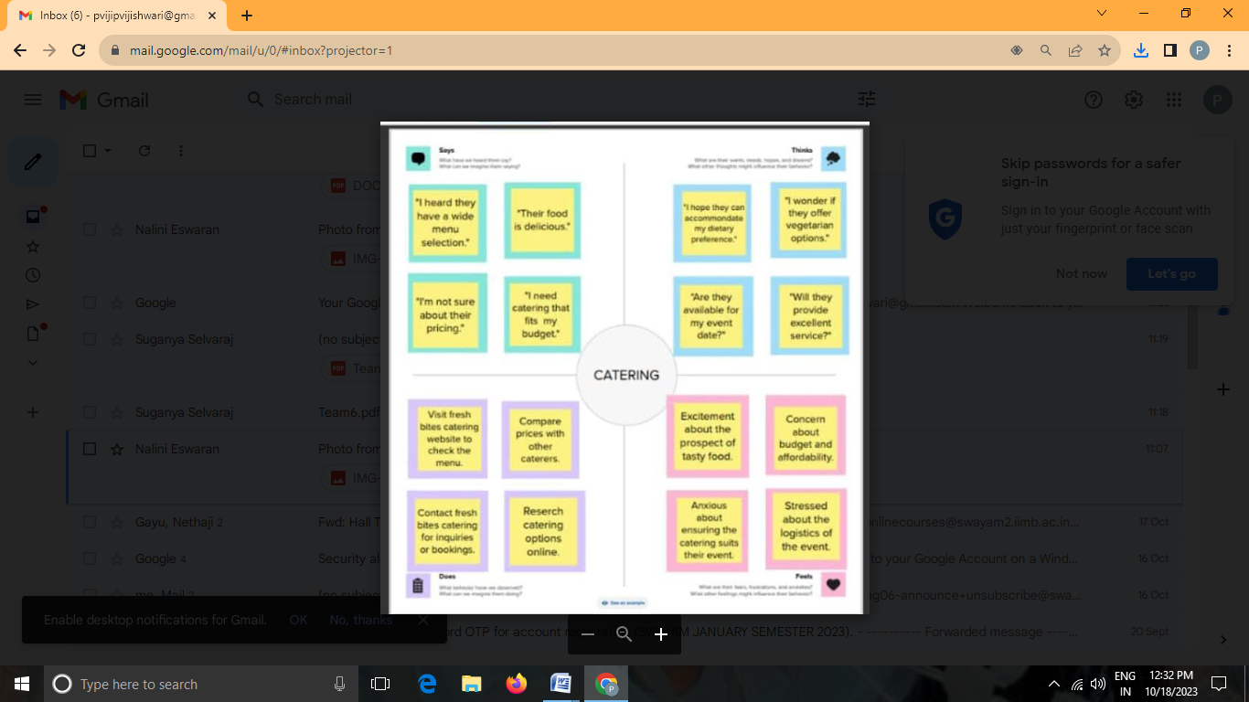

2.2 idea and brainstorming map

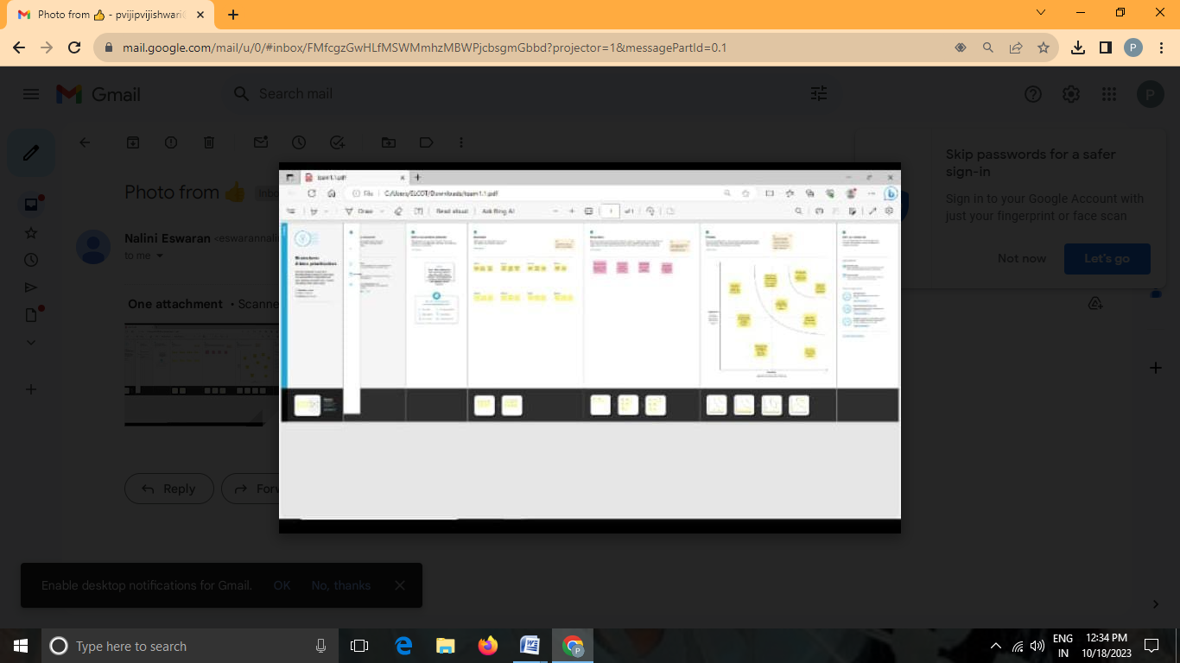

3.Result

In the result,I can find out profit and loss and balance sheet report.

PROFIT AND LOSS OUTPUT

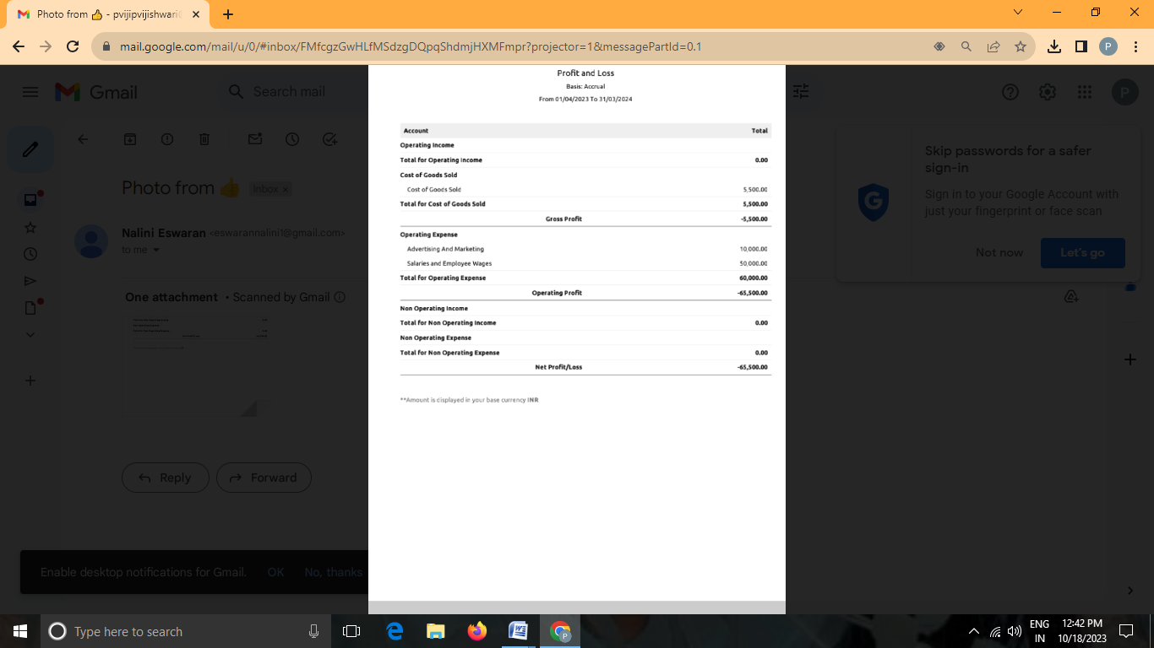

BALANCE SHEET

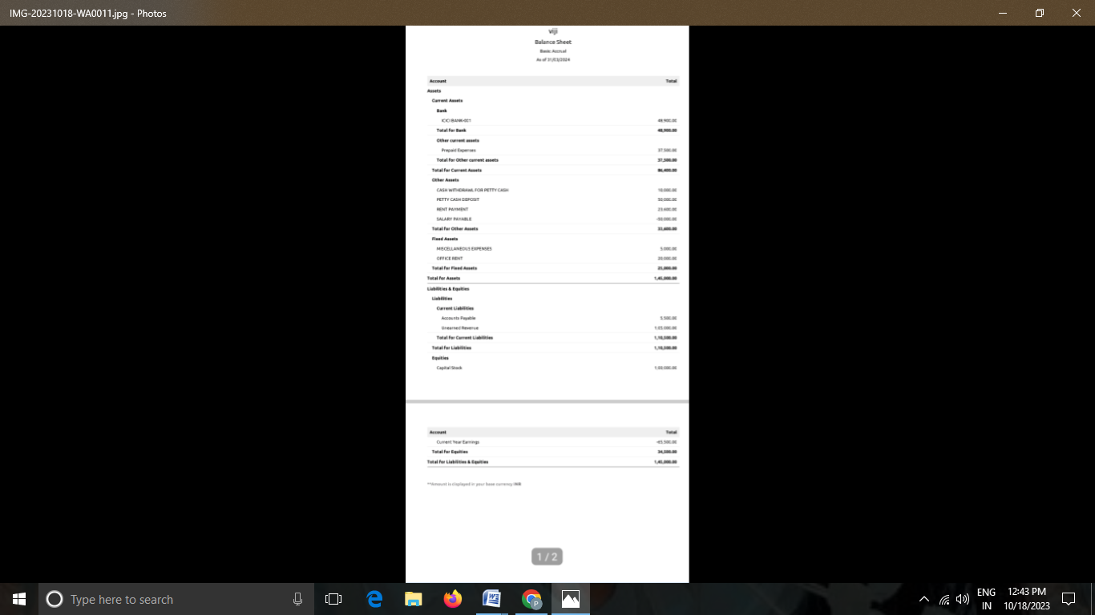

4.advantage and disadvantage

Advantage:

1.accounts maintained easily.

2.Time saving.

3.it is an easy way to create salese to purchaseorder,bill and invoices .

DIS ADVANTAGE:

1.we cannot see the customers and to talk over the customers.

5,applications:

ZHOHO books link:zhoho.com

6.conclusion:

1.first we open link and we create the organization name.

2.the zhoho books page opened ,first we create the items.

3.then,sales creation and purchase .

4.noe to create venders,purchase,order,bills, and invoices customers adding bank account and ledger jurnal entries recording banking transaction.

5.to see the report wht we can create and record .

7.future scope:

1,group scope provided complete access to all function the user can ferform on the record.

2.for instance,group scope can allow a user a user to reead create, update and delete record in all mudules.

3.the user has access to all modules in the client zhoho crm account .

8.a.source code:

1.empathy map and brainstorm link:

z.zoho book link:

books.zhoho.com